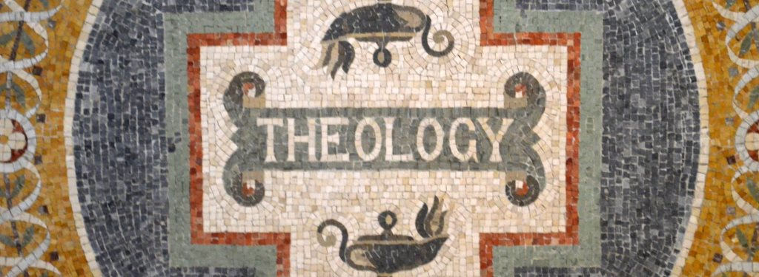

Humanity/Christ/Salvation
Institute for Biblical Studies (CRU)

Todd L. Miles, Instructor
tmiles@westernseminary.edu
(503) 517-1866

March 2020
SYLLABUS

COURSE SCHEDULE
March 23-27, 8:00a – 10:00a and 12:00p – 2:00p (PST) – Over Zoom

ORGANIZATIONAL PURPOSE
The Institute of Biblical Studies exists in order to help develop Christ-centered missionaries who possess the biblical and theological competencies they need (head, heart and hands) to live out the Great Commandment and helpful fulfill the Great Commission through the ministry of Cru. This course addresses three areas of Christian doctrine that are foundational to our life and mission.

COURSE DESCRIPTION

What is the gospel? Few questions are more fundamental to our personal lives and organizational calling than this. Although we spend a lot of time and energy strategizing how to introduce men and women to the gospel, we often spend little time reflecting on the gospel itself. Furthermore, we often live as if the gospel is only for “lost” people and not also for those of us who have been “found.” In this class we will explore historic Christian teaching regarding the doctrine of humanity, the person and work of Christ, and the doctrine of salvation. Together these doctrines shape our understanding of the gospel. We will explore the basis of salvation in the Father’s sovereign plan; the accomplishment of salvation through the life, death and resurrection of Jesus Christ; and the application of salvation to God’s children by the Holy Spirit. We will examine these doctrines as they are taught in Scripture and confessed by the church so that we may better live to the glory of the triune God (2 IBS credits)

LEARNING OUTCOMES

- Deepen your motivation to know, love and worship God and to reflect God’s character as an image-bearer.
- Develop a deeper understanding of and commitment to the foundational doctrines of the Christian faith expressed in our Statement of Faith (particularly the doctrine of humanity, the person and work of Christ, and the doctrine of salvation).
- Become persuaded that Christian theology is not just about right beliefs (orthodoxy) but also right living (orthopraxy). You will be invited to explore the ethical implications of every doctrine we study.
- Become more familiar with major viewpoints, differences, and conflicts which exist among Christians regarding these doctrines.
- Grow in your capacity to relate these doctrines to personal growth, evangelism, discipleship, movement-launching, and cross-cultural mission.
- Grow in your ability to read Scripture “theologically.”
- Be better prepared to partner with those who hold differing theological views allowing for difference of opinion on matters not central to our statement of faith and calling while pointing people to a compelling center (i.e., Christ, the gospel and our mission).
- Develop a deeper understanding of and greater confidence in the gospel of Jesus Christ as well as the need to contextualize the gospel.

TEXTBOOKS
Books
- Gregg Allison. 50 Core Truths of the Christian Life: A Guide to Understanding and Teaching Theology. Baker, 2018. ISBN: 978-0-3102-8670-7 (Chapters 15-17, 20- 21, 25-31, 33-34) (100 pages)
- Todd Miles, Superheroes Can’t Save You: Epic Examples of Historic Heresies. B&H Academic, 2018. ISBN: 978-1462750795 (all) (175 pages)
- Timothy Tennent. Theology in the Context of World Christianity: How the Global Church is Influencing the Way We Think about and Discuss Theology. Zondervan, 2007. ISBN: 978-0-3102-7511-4 (Chaps 4, 5, 6) (85 pages)
- Adrian Pei, The Minority Experience: Navigating Emotional and Organizational Realities (Downers Grove: InterVarsity, 2018), (chap 2) (I will provide)
- Richard Wayne Wills, Sr. Martin Luther King Jr. and the Image of God (New York: Oxford, 2009), (chap 5) (I will provide)
- Carl Ellis, Jr., “Preaching the Gospel Amidst Racism: Remembering Billy Graham,” Christianity Today online (Feb 24, 2018) (I will provide)
Video
- Jemar Tisby, “A Theology of Race,” May 2, 2017; Internet: https://www.youtube.com/watch?v=XgBbqi_rzuc

COURSE REQUIREMENTS

1. Attendance and Participation (20%)

You are responsible to regularly attend and participate in class discussions. The class time will be conducted seminary style, so active, prepared, and intentional student participation is necessary to maximize learning.

2. Reading (30%)

All reading is to be completed prior to our first class meeting on March 23. Reading completed by March 27 will receive 90% credit. Reading completed by April 6 will receive 80% credit. A reading log is attached at the end of the syllabus.

- Theologia Viatorum (50%)
God has made a way for us to know him; we are on our way to knowing God. This is an apt summary of the Christian life and, prayerfully, our course this semester. To help work our theology deep down and to move it from the lectern to personal liturgies, we will use this project to build a spiritual discipline of theology and a theology of spiritual disciplines for this semester and life. The purpose of our project: to create a biblical theological lens that interprets, clarifies, and reinvents our world from a divine perspective for worship of the triune God.
This is the life project of all theologians and all are theologians (the only question is degree of faithfulness). We seek to understand our context and work our way heavenward by God’s providential designs. This is what the thologia viatorum is: a theology of pilgrims for their way to the Celestial City where we will enter our graduate course in the theologia beatorum (theology of the blessed).
Our general structure will be as described below and I will provide you with an organizing handout for Anthropology (What is a human and what is it to be created in the image of God?) including texts and instructions.
- Contextualization: Due March 23 (Pre-class work)
  - Before you begin your reading for the class and the rest of the viatorum, take a moment and jot down in outline form (1/2 page to 1 page total) what you already know about this specific viatorum topic and how it has influenced your worldview.
  - This can (and should) be unpolished and incomplete. This section often looks more like a brainstorm session than a final product.
  - Make sure to include the “where and how” of what you learned here. You are seeking an autobiography of your theological context here. It is fine if you do not remember, but try your best.
- Meditation: Due March 23 (Pre-class work)
  - Read and meditate on 1-3 provided biblical passage(s) central to the doctrine being covered.
  - Spend an hour on each text before moving forward in the assignment.
  - Record of Findings: In 2 paragraphs per passage (500 words total per passage) explain how God transformed your mind and heart regarding the topic at hand through the text.
  - State the purpose of the passage in 1 sentence at most and speak to transformation in 3-6 sentences.
  - Be specific, particular, honest, transparent, and direct in your transformation.
- Exploration: Due April 6 (Post-class work)
  - I will provide you with several main questions concerning the doctrine in view.
  - Answer these according to the instructions provided.
  - Reading and research help here. Make sure that you cite those who help you in footnotes (biblical references can be handled parenthetically (e.g., Ps 19:1)).
- Synthesis: Due April 6 (Post-class work)
  - Use one page to take all that you have learned in your “exploration” section to provide a short, succinct article on this aspect of the Christian faith.
  - This section will be 2 pages in length at most.
- Application: Due April 6 (Post-class work)
  - Provide a list of 5-10 short sentences explaining how this doctrine changes you in the following ways: personally, socially, ecclesially, ethically, and eschatologically.
  - Be specific and practical here.
- Destination: Due April 6 (Post-class work)
  - Provide 2-3 questions that you would like to investigate further.
  - For each question, list 2 ways you will find your answers and 3 (scholarly) sources you will seek out to answer your questions.
You will complete the Viatorum with the goal being succinct evidence of depth and transformation in all of the sections.

COURSE SCHEDULE

Monday – Doctrine of Humanity
Tuesday – Doctrine of Humanity/ Doctrine of Sin
Wednesday – Doctrine of Person of Christ
Thursday – Doctrine of Work of Christ
Friday – Doctrine of Salvation

GRADING

94-100 A  92-93 A-  90-91 B+  84-89 B  82-83 B-  80-81 C+ | 74-79 C  72-73 C-  65-71 D  0-65 F

COURSE POLICIES

Assignment Format:

Unless otherwise indicated, all assignments must meet the following criteria:

- 1 ” margins on the left, right, top, and bottom
- Double-spaced
- 12 point font (Times New Roman or Arial)
- A cover page that contains the assignment title, class title, your name, and date
- Please submit to me as .doc, .docx, or .pdf documents. (I cannot read .pages docs.)

Reading Log
Please email to course instructor by 4/06/20

Allison 50 Core Truths of the Christian Life: (Chapters 15-17, 20- 21, 25-31, 33-34)

Date Completed _________________-0r- % completed by 4/6 _____________

Miles. Superheroes Can’t Save You: (All)

Date Completed _________________-0r- % completed by 4/6 _____________

Tennent. Theology in the Context of World Christianity: (Chapters 4, 5, 6)

Date Completed _________________-0r- % completed by 4/6 _____________

Ellis. “Preaching Redemption Amidst Racism: Remembering Billy Graham”
Date Completed _________________-0r- % completed by 4/6 _____________

Pei. The Minority Experience (chap 2)
Date Completed _________________-0r- % completed by 4/6 _____________

Wills. MLK and the Image of God (chap 5)
Date Completed _________________-0r- % completed by 4/6 _____________

Watch Jemar Tisby on “Theology of Race”
Date Completed _________________-0r- % completed by 4/6 _____________

