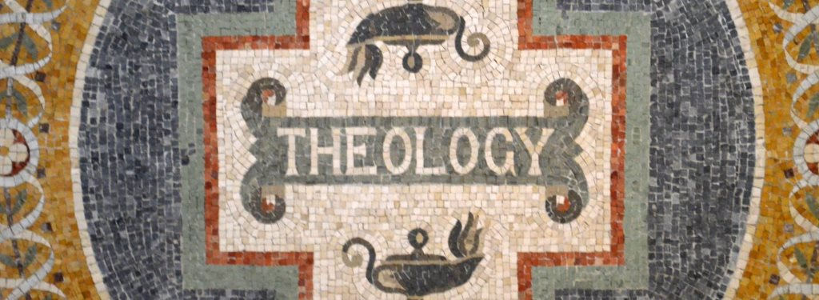

Bible/God/Holy Spirit
Institute for Biblical Studies (Cru)

Todd L. Miles, Instructor
tmiles@westernseminary.edu
(503) 517-1866

January 2019
SYLLABUS

COURSE SCHEDULE
Jan 7 – Jan 11, 9:30a – 11:30a and 1:00p – 3:00p, at Xenia OH

ORGANIZATIONAL PURPOSE
The Institute of Biblical Studies exists in order to help develop Christ-centered missionaries who possess the biblical and theological competencies they need (head, heart and hands) to live out the Great Commandment and helpful fulfill the Great Commission through the ministry of Cru. This course addresses three areas of Christian doctrine that are foundational to our life and mission.

COURSE DESCRIPTION

In his classic book The Knowledge of the Holy, A. W. Tozer explains, “What comes into our minds when we think about God is the most important thing about us. . . . For this reason, the gravest question before the Church is always God himself, and the portentous fact about any man is not what he may at a given time say or do but what he in his deep heart conceives God to be like.” This course offers an opportunity to broaden and deepen your understanding of the God whom we love and worship.

To this end, we will explore Christian teaching regarding the nature and attributes of God, the persons of the Trinity, the inspiration and authority of Scripture, and the person and work of the Holy Spirit. You will better understand how one God has revealed himself to us as Father, Son and Holy Spirit. You will gain greater confidence in Scripture as the inspired, truthful, authoritative, sufficient and powerful Word of God. You will discover how the Holy Spirit enables you to grow in conformity to the image of Christ and empowers God’s people to bear witness about Christ to the ends of the earth. We will examine these doctrines as they are taught in Scripture and confessed by the church so that we may better live to the glory of the triune God (2 IBS credits – Theology and Apologetics).

LEARNING OUTCOMES

Affective (attitudes, motivation, character)
- Deepen your motivation to know, love and worship the triune God and reflect God’s character as image-bearers.
- Gain greater confidence in Scripture as the inspired, truthful, authoritative, sufficient and powerful Word of God.
- Grow as a disciple of Jesus who joyfully submits to the authority of God’s Word and who builds movements of disciples who “truly follow Jesus” by embracing his Word in their lives.
Cognitive (knowledge and thinking skills)
- Deepen your understanding of the nature and attributes of God, the persons of the Trinity, the inspiration and authority of Scripture, and the person and work of the Holy Spirit as these doctrines are taught in Scripture and confessed by the church.
- Become more familiar with viewpoints, differences, and conflicts which exist among Christians regarding these doctrines as well as the way culture shapes our theologies.
- Develop a deeper understanding of and commitment to the Cru Statement of Faith.
- Become persuaded that Christian theology is not just about right beliefs (orthodoxy) but also right living (orthopraxy).

Behavioral (personal and ministry skills)
- Grow in your capacity and motivation to read Scripture “theologically.”
- Grow in your capacity to teach these foundational doctrines from Scripture and relate them to evangelism, discipleship, movement-launching, ethics, and cross-cultural mission.
- Be better prepared to partner with those who hold differing theological views allowing for difference of opinion on matters not central to our Statement of Faith and calling while pointing people to a compelling center (i.e., Christ, the gospel and our mission).

TEXTBOOKS
Books
- Gregg Allison. 50 Core Truths of the Christian Life: A Guide to Understanding and Teaching Theology. Baker, 2018. ISBN: 978-0-3102-8670-7 (Chapters 1-13, 22-24)
- Todd Miles. A God of Many Understandings: The Gospel and a Theology of Religions. B&H, 2010. ISBN: 978-0-805-44822-1 (Only chapter 8 – This will be emailed to you)
- Michael Reeves. Delighting in the Trinity: An Introduction to the Christian Faith. Zondervan, 2012. ISBN: 978-0-8308-3983-4
- Timothy Tennent. Theology in the Context of World Christianity: How the Global Church is Influencing the Way We Think about and Discuss Theology. Zondervan, 2007. ISBN: 978-0-3102-7511-4 (Chapters 1-2, 7)
Other readings:
- Carl Ellis, “Biblical Righteousness Is a Four-Paned Window,” The Gospel Coalition (August 22, 2018).
COURSE REQUIREMENTS

1. Attendance and Participation (20%)
You are responsible to regularly attend and participate in class discussions. The class time will be conducted seminary style, so active, prepared, and intentional student participation is necessary to maximize learning.

2. Reading (20%)
All reading is to be completed prior to our first class meeting on January 7. Reading completed by January 11 will receive 90% credit. Reading completed by January 25 will receive 80% credit. A reading log is attached at the end of the syllabus.
3. Theology Project (40%)
You will write a paper in which you present Scriptural teaching on the person and work of the Holy Spirit. The goal is to be as comprehensive as you can be, exposing the richness of the Bible’s own teaching on the Holy Spirit. In order to write this paper, you will need to take the following steps:
- Choose: Pick one of the following options:
- Doctrine of the Holy Spirit as taught in the book of John
- Doctrine of the Holy Spirit as taught in the book of Acts
- Doctrine of the Holy Spirit as taught in the book of 1 Corinthians
- Doctrine of the Holy Spirit as taught in the book of Romans
- Explore: Read through the whole book noting every reference to the Holy Spirit (the Spirit might have a name other than “Holy Spirit”). For each reference to the Holy Spirit, record your observations. Here are some questions you might try to answer. What do you learn from this passage about the person of the Holy Spirit (deity, personally)? What do you learn about the work the Holy Spirit (in the life of Christ, the church, unbelievers, believers)? Does the passage say anything about the how the Holy Spirit relates to the Father and/or Son? You may find it helpful to see what commentators say about your passage (e.g., ESV Study Bible notes). You might also consult at the Scripture index in Grudem’s Systematic Theology to see if he discusses any of the key passages in your book.
- Synthesize: What stands out to you regarding the person and work of the Holy Spirit in this book? Do you see any recurring themes? What patterns do you observe about the working of the Holy Spirit? Are certain aspects of salvation associated with Holy Spirit? How does the Holy Spirit relate to other divine persons? Consider how best to organize these teachings into a systematic and coherent whole.
Write: Drawing your work together, write a paper (7-9 pages, double spaced, 12 pt. font) summarizing what you learned. To the best of your ability, present all that your book says about the Holy Spirit. Endeavor to be faithful to the intended meanings of each individual teaching in its context, while displaying how they these contribute to a holistic understanding of this doctrine. Remember that this is not a verse by verse commentary but a carefully crafted synthesis of the doctrinal teaching of your book on the person and work of the Holy Spirit. You will need to think about how best to structure your presentation. In the last page of your paper, address the following questions: What was the most helpful thing you learned about the Holy Spirit from your study? What implications does this have for ministry? What implications does your study have for Christian ethics? (Think about Dr. Ellis’ “four window-panes of righteousness” as you reflect on the ethical implications.) DUE: Reports are due January 25.

4. Meditation Project (20%)
- For two weeks, please meditate on Ephesians 1:3-14. Pay careful attention to what member of the Trinity does what.
  - Read the passage (preferably aloud) at least once per day, five days per week, for two weeks.
  - Summarize insights from your meditations in a two-page paper.
  - Include insights on what the passage teaches and how you might apply the truths of the passage to your life and ministry.
- For two weeks, please meditate on John 14:15-31; 15:26-16:15. Pay careful attention to what member of the Trinity does what.
  - Read the passage (preferably aloud) at least once per day, five days per week, for two weeks.
  - Summarize insights from your meditations in a two-page paper.
  - Include insights on what the passage teaches and how you might apply the truths of the passage to your life and ministry.
- Meditations are due 1/11.
COURSE SCHEDULE

Monday – Prolegomena
Tuesday – Doctrine of God
Wednesday – Doctrine of God
Thursday – Doctrine of Scripture
Friday – Doctrine of the Holy Spirit
GRADING

94-100 A  92-93 A-  90-91 B+  84-89 B  82-83 B-  80-81 C+ | 74-79 C  72-73 C-  65-71 D  0-65 F
COURSE POLICIES

Assignment Format:

Unless otherwise indicated, all assignments must meet the following criteria:

- 1 ” margins on the left, right, top, and bottom
- Double-spaced
- 12 point font (Times New Roman or Arial)
- A cover page that contains the assignment title, class title, your name, and date
- Please submit to me as .doc, .docx, or .pdf documents. (I cannot read .pages docs.)

Reading Log
Please email to course instructor by 1/25/19

Allison 50 Core Truths of the Christian Life: (Chapters 1-13, 22-24)

Date Completed _________________-or- % completed by 1/25 _____________

Miles. A God of Many Understandings: (Only chapter 8)

Date Completed _________________-or- % completed by 1/25 _____________

Reeves. Delighting in the Trinity: An Introduction to the Christian Faith (entirety)

Date Completed _________________-or- % completed by 1/25 _____________

Tennent. Theology in the Context of World Christianity: (Chapters 1-2, 7)

Date Completed _________________-or- % completed by 1/25 _____________

Ellis, “Biblical Righteousness Is a Four-Paned Window,” (entirety)

Date Completed _________________-or- % completed by 1/25 _____________

